Walkthrough Method of Snapchat ( UI analysis)

Home screen/ Social Hub :
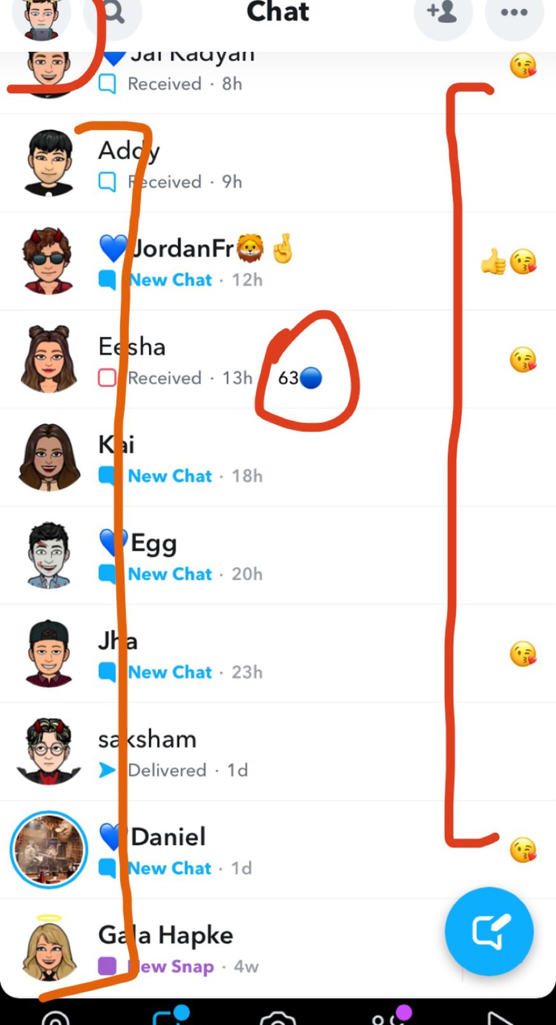
- Your avatar is your main identity on the app
- Each one has a unique avatar and they go by that identity ONLY on the app ( no irl dps)
- Vertical design: easy to navigate and addictive
- Certain emojis are used to denote friendships with other users of the app
- 63- snapstreak: when u and another snap users exchange a picture with one another everyday to build a streak. - increases daily user engagement on the app
- Color of notifications : blue
Snapchat’s homepage is the main hub the user interacts while using the app.
It is purely a social space: just chatting
Snapchat’s unique charm is that you can chat with your friends by sending a text message or a picture which only lasts for how long the user wants it to. The user is also alerted when the snap they have sent is screenshoted or saved by the person he sends it to- This gives the user a sense of security on the platform, it allows them to express themselves with no judgement.
‘Filters’ is also an xfactor of snap when it comes to experiencing one’s self- it gives the user a completely different look- they can look nicer on camera and send pics of themselves to their friends- confidence boost
Having a unique avatar as your dp instead of an irl pic is another xfactor of snap- this gives the user the power to be whoever or whatever they want- prefect eco-system for a second life.

Overall: Snap’s main hub is very lively. Lots of faces and emojis. The unique friend emoji which denotes friendships is highly incentivizing for the user. Opening this platform truly feels like an escape.

- Easy to navigate UI
- Users can swipe in between the various spaces the app has to offer
- Vertical consumption, Horizontal navigation

Stories page (express yourself) :

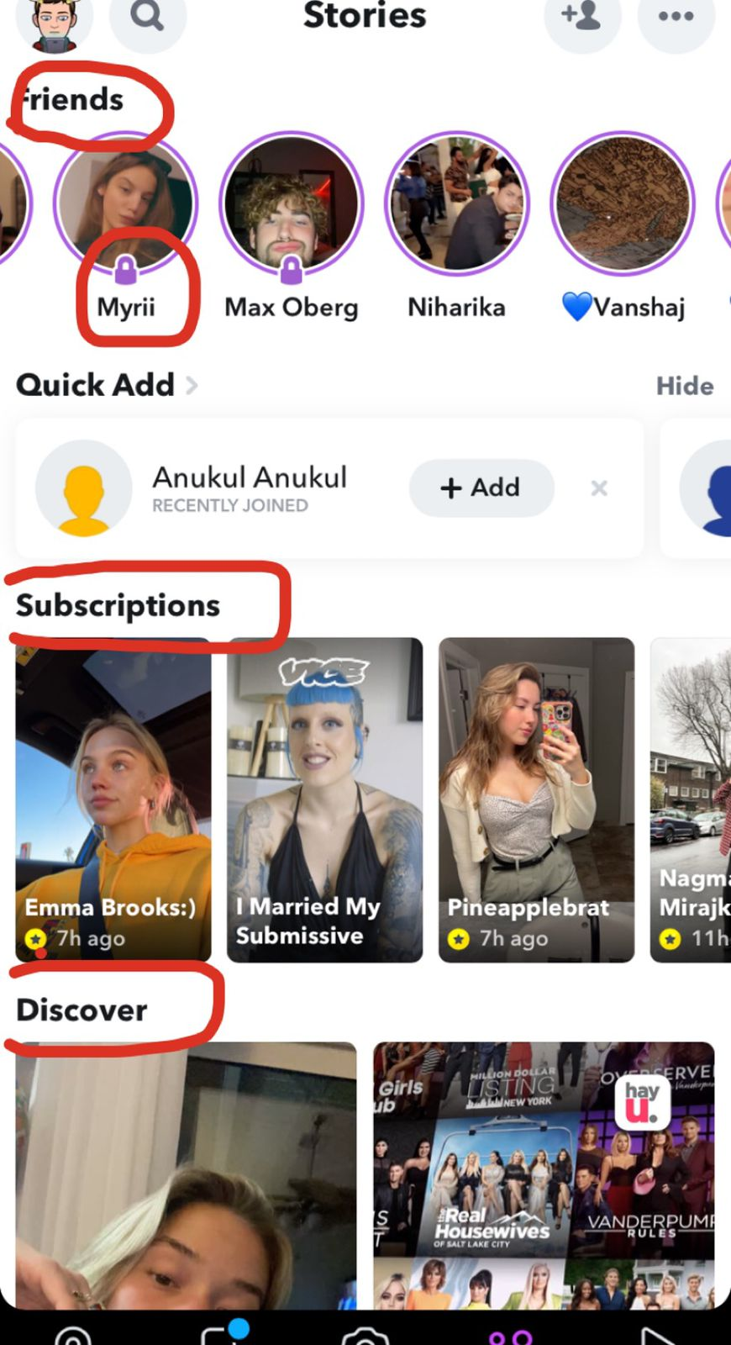
- Story: life updates/ showing off/ way of expressing urself on the app
- A story update only last 24 hrs – privacy and attention snap
- The users is first shown story updates of his/her friends, if lucky enough, he/she can views their friends ‘private story’ : small lock shown under the story which denotes they can view their private stories
- Right under their friends, users can view stories of their ‘subscriptions’ : basically means stories of influencers/ big personalities
- Then, user can engage with ‘Discover’ feature : an fyp, an allog which shows other snap profiles u could be interested in based on ur pages u follow and engage with

The stories hub is really well planned too. Friends first attitude.
The concept of a priv story adds another layer of privacy to the user- basically their ‘inner circle’
Being part of someone else’s inner circle and having a visual representation of that on the stories screen gives user sense of importance
Discover + Explore = endless content for the cons
umer thru an allgo therfore addictive

Spotlight ( their reels) :
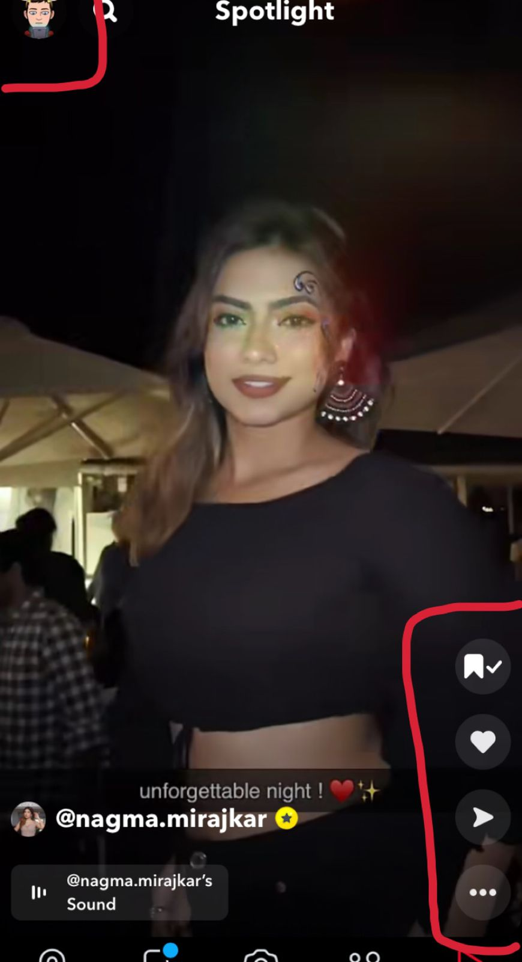
- Vertical design
- Fool-proof addictive design
Spotlight hasn’t taken off much on snap, it seems forced. Addition of this feature was done just for the heck of it- doesn’t offer anything unique.

Friend Emojis:

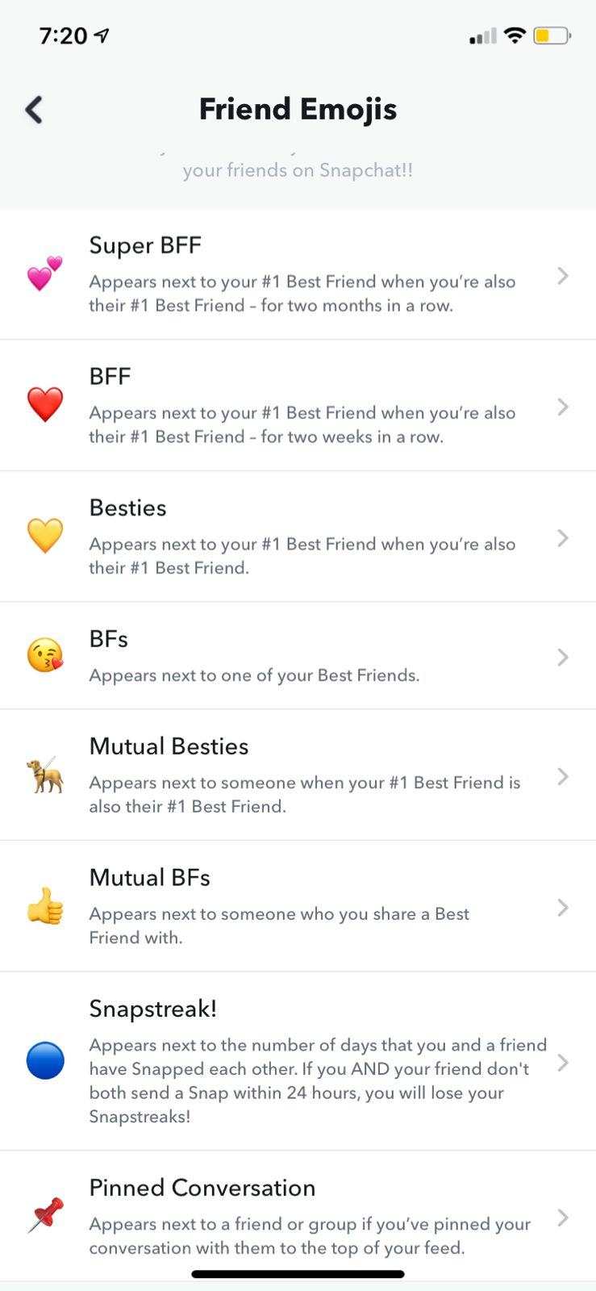
A great feature for long-term engagement. Modern trends have taught us that gen z love emojis. Sort of friendship badges. Having this reward system in place, users are incentivized further to social on the app to their these emojis which therefore brings them back to the app multiple times a day.

Snapmaps:

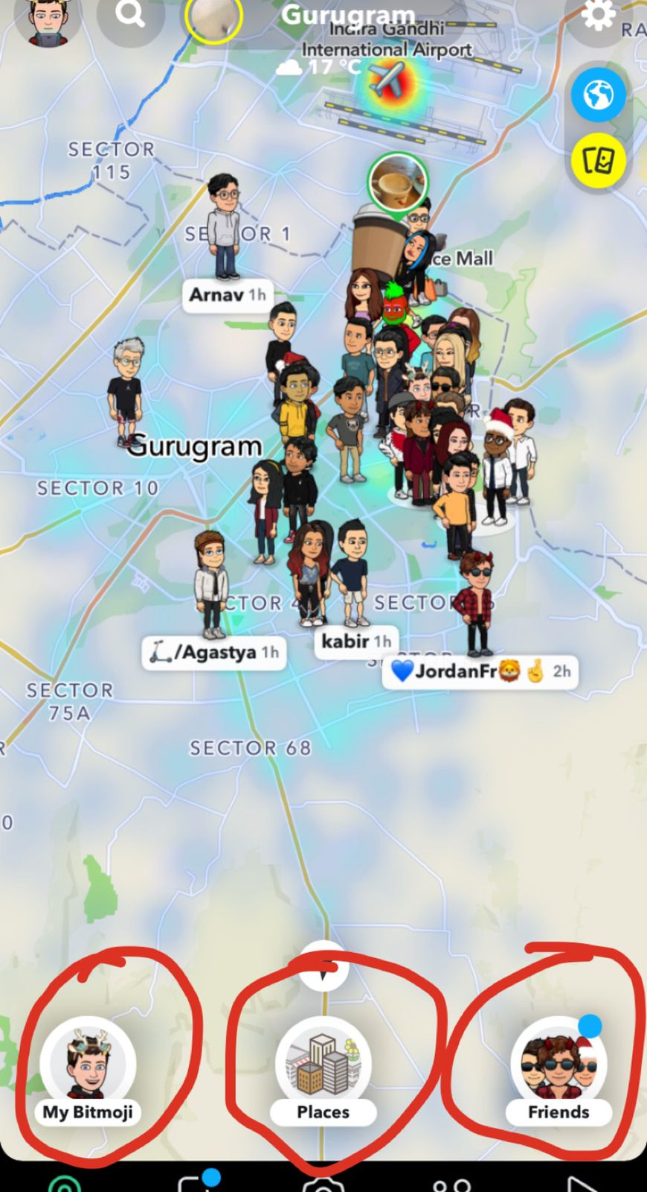
- 3 UI features : My bitmoji, Places and Friends
- Clear by now thay user’s identity on snap is via their self-made widely customizable bitmoji
- Over the top feature : not loved my most

IDENTITY :
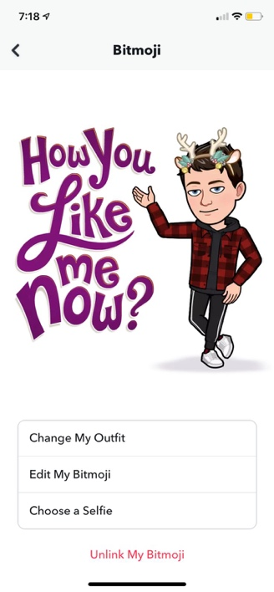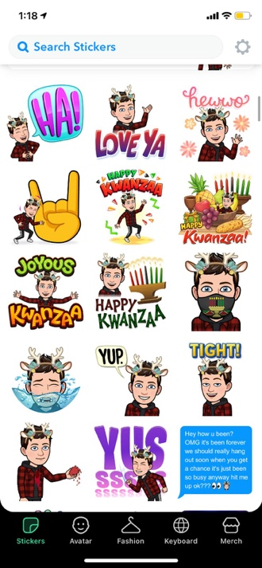
- Bitmoji: very personal and expressive
- ONLY FORM OF INDENTIY ON THE APP BITMOJI + DISPLAY NAME
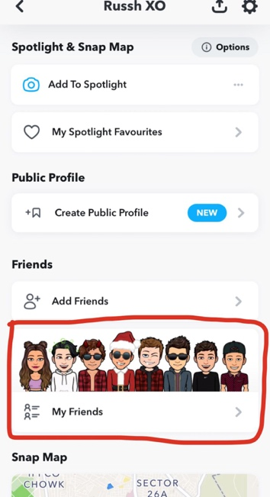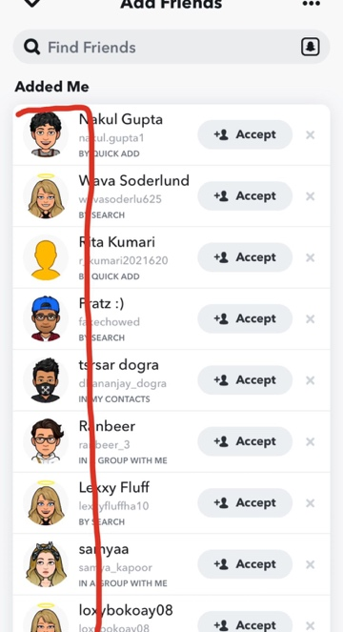
- User’s friends and other potential friends are also identify by their bitmoji
With the use of bitmoji, snapchat has successfully made a unique second life exp which is nothing like instagram, facebook & whatsapp - maybe that’s why genz ( and myself) use it and love it soo much
Note: show the dept of bitmoji customisation

Metaverse features of Snapchat :

A second life identity is present on snapchat. To complement this, there are a lot of activities and games the user can play on the app- their bitmoji being the main character.

- A wide range of games which user can play with their friends on gc. Communication done via texts or voice chat.
These snap games can also be played alone with random people from around the world.

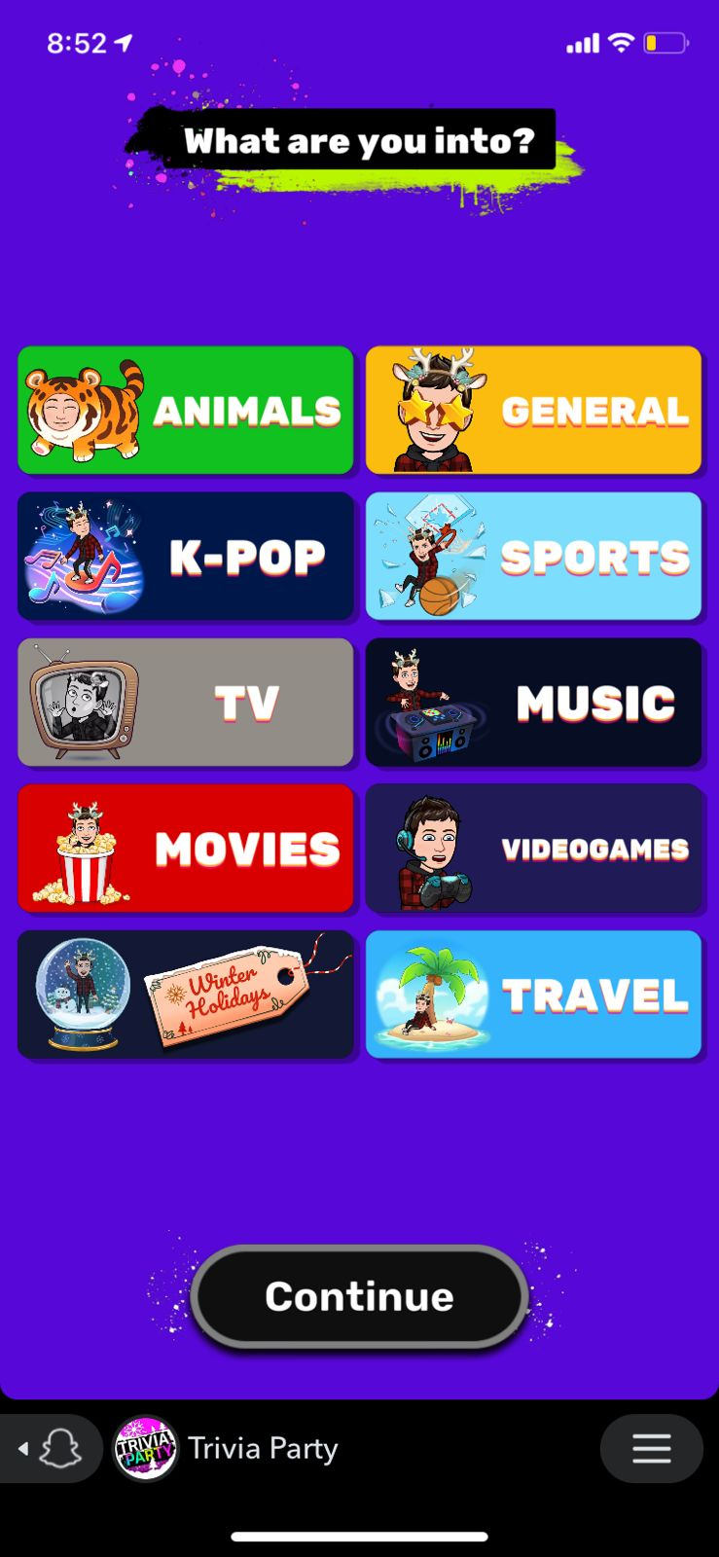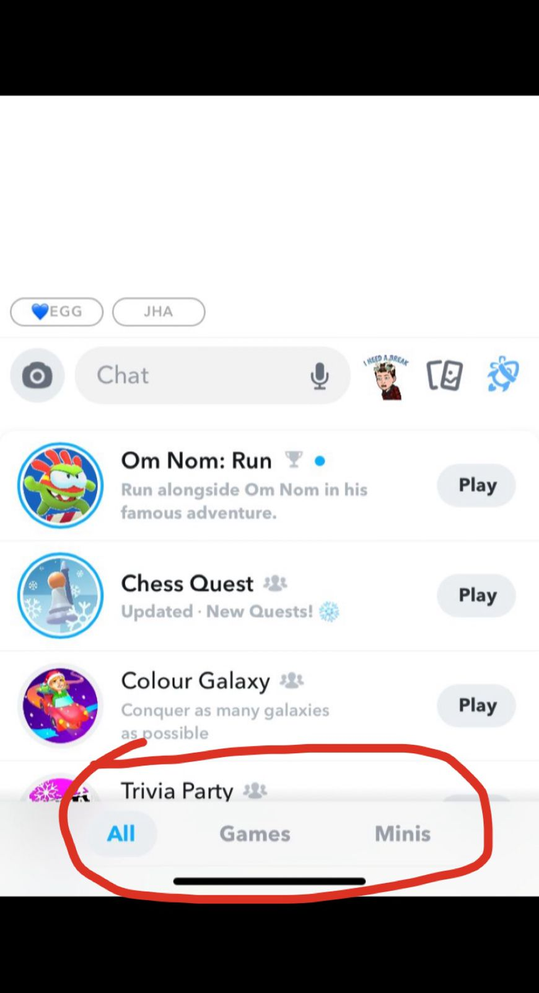

- Addictiveness and daily engagement +++++++++++

- Bitmoji parties: virtual spaces where user can hangout and do other party related activities virtually with either their friends or random users from around the world.
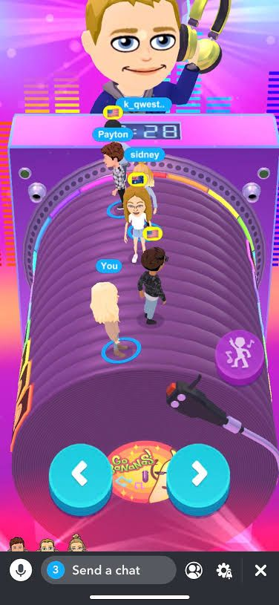

- Same principle : bitmoji is the main character- great feature, hasn’t been used a lot but has tons of potential. To further the second life exp, very whimsical / futuristic/ peppy settings are used for their virtual meet ups.

- NFTs
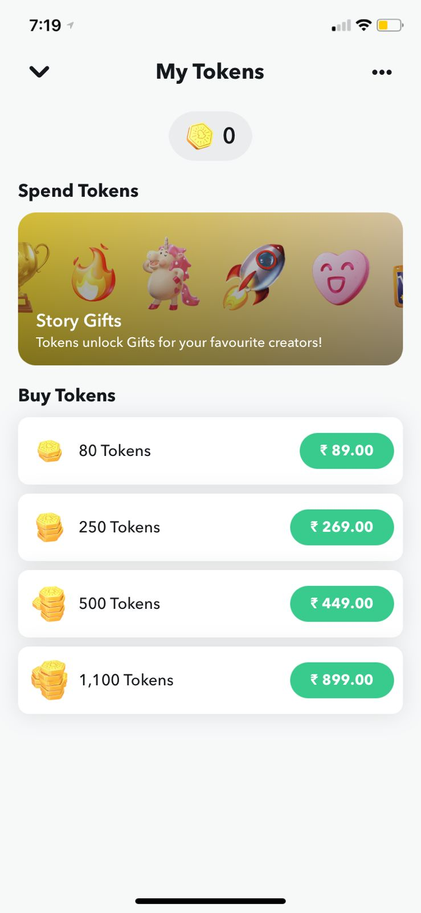
Currently in beta version.
Snap tokens are digital content that can only be purchased from snap and redeemed on snapchat for digital goods. Purely collectibles, they hold no monetary value like other nfts.

